Walk 42 The Cradley Brook
Last walked in November 2016

Description. A 7 km (4.3 miles). A pleasant stroll for a summer's evening or a winter's afternoon.
Start. Stifford’e Bridge on the A4103. Explorer Map 190. Grid 734481.
Directions from Whitecross Roundabout (turn milometer to zero). From Whitecross roundabout[0m]: Take the A4110 Canon Pyne (Three Elms road) for 1 mile and TR at the traffic lights onto the A4103 Worcester (Roman road). After 18 miles you pass the Red Lion Inn on the R, a little further on you can park up on the R hand side of the road.

1. Red Lion Inn. Walk back towards Hereford on the A4103, over the bridge and past the Red Lion Inn (L). 50m past the Red Lion, TL and walk along an enclosed track that’s at the end of a tall wooden fence and garden. Cross over a stile into field 1 {F1}; keep the fence on your L and cross another stile in the corner of a field into an orchard. Continue in the same direction, keep to the fence on your L and at the end of the orchard you go thru a small metal gate to cross a track/ driveway and on thru a kissing gate into {F2}. With the hedge on your L, continue downhill, crossing over two stiles separated by a tarmac driveway and into {F3}. Keep hedge on your L as you continue in the same direction (ignore the stile on the L). At the bottom of the hill follow the fence around to the R. Cross a way marked stile/metal gate (L) into {F4}, and continue up hill following a gully that’s on your L. At the end of {F4} you continue on thru the gully. Cross a stile, and continue on thru an enclosed path. Cross over a tarmac road and continue along a well-defined track. Cross over another tarmac road and go thru a small wooden gate and along an enclosed track with wall/trees on your R.

2. Wooden Footbridge. Cross over a wooden footbridge into {F5}; keep to the hedge on your R and go thru a kissing gate and onto an enclosed farm track. There is a house on your L. Continue in the same direction as you follow the way mark sign and pass thru a metal gate into {F6}, fence/hedge is now on your L. Keep to the hedge as it bends to the L. Cross over a stile and a wooden bridge into {F7} and continue up, keeping hedge then wooden fence to your L. At the end of the wooden fence/field TL thru a kissing gate. After a few metres TR along a driveway and out onto a road. TL, go along the road and over a bridge, pass a gate on the R sign ‘Overley’, and about 50m further on TR to cross over a stile into {F8}. Bear slightly R as you cross the field, and after about 100m you TR at a way marker post, heading towards the woods and a church that is beyond the wooded area. At the edge of this field you cross over a well defined stone track (to ‘Overley’) and across a stile to continue on, to cross over a stone footbridge into {F9}. Cross the field and head towards the L hand side of a church to a kissing gate. Continue along an enclosed track to the main road.

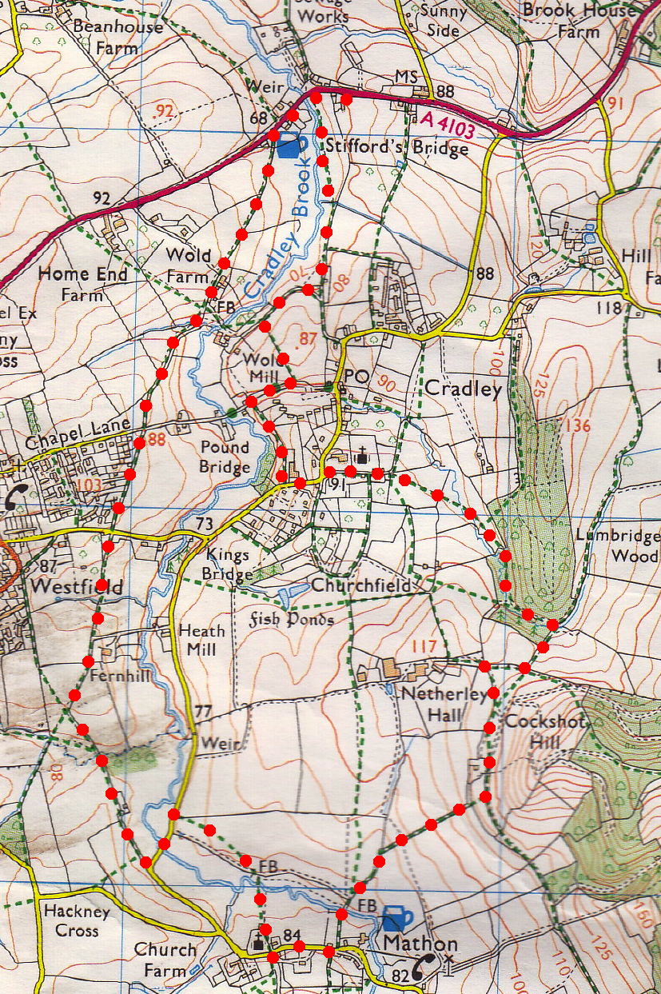
3. School House. TL and walk along main road passing a school house on the L and then just passed a black and white house called Badgers, TL thru a wooden gate to follow an enclosed public footpath signed for Cradley ¾ mile. Cross a wooden footbridge and continue onto a tarmac drive where you TR. Continue up the drive for about 250m, and when it bends to the L by a gate, TR and walk up 7 wooden steps and into {F10}. Go straight across the field to cross over a stile and TL, walk along a track, keeping a fence on your L. Some way along the track goes thru two wooden sleepers. Keep fence on your L as you go slightly downhill to reach a drive and metal gate that leads to the red-bricked farmhouse. TR, walk away from the farm house and along the track, the fence is on your L, (you pass a small corrugated shed (L). Go thru a metal gate into {F11}. TL and follow the track towards the woods, after about 80m and just before the track bends R, TL into the woods to go thru a small wooden gate and across a footbridge. Cross over a stile and TL to follow a track, which will bend around to the R, (ignore the way marked track that crosses the river to your L). Keep the stream on your L, further on you cross another stile out of the woods and into {F12}, (ignore the track near to the stile that goes off to the R). Walk along the middle of the field and TL after about 120m to cross over a stone bridge and head towards a church. Cross a couple of fields and a stile to go thru metal gates and onto a wide enclosed stone track.
1

4. Cradley. Continue along the track/road; pass a fifteenth century former school and an old church on your R to reach a war memorial by a main road. Cradley is the largest Parish in Herefordshire. It has St James Church that existed before the Normans came; it is set in beautiful traditional English country surroundings. Cradley Village Hall, is a 16th Century timbered building, recently renovated and restored after a serious fire destroyed a large part of the roof. Bear slightly L and follow the road downhill towards Mathon. After about 100m you TR and cross a stile to continue along and enclosed footpath which is just passed Old School Close. Continue along to the end of the track, crossing another two stiles to reach the road by Brook Cottage which is on the L. TR, the stream is on your R. TL at the first stile on your L that’s just before the road bends to the R, and head up {F13}. Continue on with the tree line on your L and cross a stile by a wooden gate and carry on down to the tarmac road. TR and continue along the road to the first turning on the L, which is a drive. TL and walk along the drive to cross a stile/wooden gate and walk along an enclosed track. Carry on thru three large fields, keeping the river on your L, to reach the main road where you TR to walk up to the waiting car.
2
4

3

